Text: Ephesians 4:15-16 (CSB)
¹⁵ But speaking the truth in love, let us grow in every way into him who is the head—Christ. ¹⁶ From him the whole body, fitted and knit together by every supporting ligament, promotes the growth of the body for building itself up in love by the proper working of each individual part.

God Has a Pattern for Church Growth, It Still Works Today:
- Acts 2:41-47 (CSB)

Acts 2:41-47 (CSB)
⁴¹ So those who accepted his message were baptized, and that day about three thousand people were added to them. ⁴² They devoted themselves to the apostles’ teaching, to the fellowship, to the breaking of bread, and to prayer.
⁴³ Everyone was filled with awe, and many wonders and signs were being performed through the apostles. ⁴⁴ Now all the believers were together and held all things in common. ⁴⁵ They sold their possessions and property and distributed the proceeds to all, as any had need. ⁴⁶ Every day they devoted themselves to meeting together in the temple, and broke bread from house to house. They ate their food with joyful and sincere hearts, ⁴⁷ praising God and enjoying the favor of all the people. Every day the Lord added to their number those who were being saved.

Growth Happens When Every Member Uses Their Spiritual Gift Organization:
- Romans 12:1-8 (KJV)

Romans 12:1-8 (KJV)
¹ I beseech you therefore, brethren, by the mercies of God, that ye present your bodies a living sacrifice, holy, acceptable unto God, which is your reasonable service. ² And be not conformed to this world: but be ye transformed by the renewing of your mind, that ye may prove what is that good, and acceptable, and perfect, will of God. ³ For I say, through the grace given unto me, to every man that is among you, not to think of himself more highly than he ought to think; but to think soberly, according as God hath dealt to every man the measure of faith.

⁴ For as we have many members in one body, and all members have not the same office: ⁵ So we, being many, are one body in Christ, and every one members one of another. ⁶ Having then gifts differing according to the grace that is given to us,

Organization Is Not Unspiritual; It’s Biblical and Releases Spiritual Power:
- Titus 1:5 (CSB)
- Acts 6:1-7 (CSB)

Titus 1:5 (CSB)
The reason I left you in Crete was to set right what was left undone and, as I directed you, to appoint elders in every town.

Acts 6:1-7 (CSB)
¹ In those days, as the disciples were increasing in number, there arose a complaint by the Hellenistic Jews against the Hebraic Jews that their widows were being overlooked in the daily distribution. ² The Twelve summoned the whole company of the disciples and said, “It would not be right for us to give up preaching the word of God to wait on tables. ³ Brothers and sisters, select from among you seven men of good reputation, full of the Spirit and wisdom, whom we can appoint to this duty. ⁴ But we will devote ourselves to prayer and to the ministry of the word.” ⁵ This proposal pleased the whole company. So they chose Stephen, a man full of faith and the Holy Spirit, and Philip, Prochorus, Nicanor, Timon, Parmenas, and Nicolaus, a convert from Antioch. ⁶ They had them stand before the apostles, who prayed and laid their hands on them. ⁷ So the word of God spread, the disciples in Jerusalem increased greatly in number, and a large group of priests became obedient to the faith.

Spiritual Gifts Point You to Your Place in the Church:

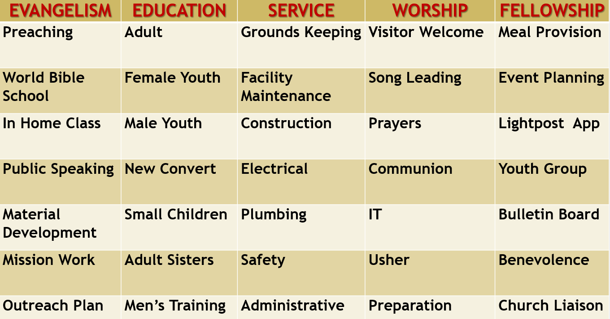

A Committed Unified Church is a Growing Church:
- Philippians 1:27 (KJV)
- Nehemiah 2:17–18 (CSB)

Philippians 1:27 (KJV)
Only let your conversation be as it becometh the gospel of Christ: that whether I come and see you, or else be absent, I may hear of your affairs, that ye stand fast in one spirit, with one mind striving together for the faith of the gospel;

Nehemiah 2:17–18 (CSB)
¹⁷ So I said to them, “You see the trouble we are in. Jerusalem lies in ruins and its gates have been burned. Come, let’s rebuild Jerusalem’s wall, so that we will no longer be a disgrace.” ¹⁸ I told them how the gracious hand of my God had been on me, and what the king had said to me. They said, “Let’s start rebuilding,” and their hands were strengthened to do this good work.

RESPONSE TO THE INVITATION OF FAITH:
1. HEAR the GOSPEL ~ Romans 10:17
So then faith cometh by hearing and hearing by the word of God.
2. BELIEVE ~ Hebrews 11:6
But without faith it is impossible to please Him, for he that cometh to God must believe that He is and He is a rewarder of them that diligently seek Him.
3. REPENT ~ Luke 13:3
I tell you nay; but except ye repent ye shall all likewise perish.
4. CONFESS ~ Matthew 10:32-33
Whosoever therefore shall confess me before men, him will I confess also before my Father which is in heaven. But whosoever shall deny me before men, him will I also deny before my Father which is in heaven.
5. BE BAPTIZED ~ Acts 22:16
And now why tarriest thou? arise, and be baptized, and wash away thy sins, calling on the name of the Lord.
6. BE FAITHFUL UNTO DEATH ~ Revelation 2:10
Fear none of those things which thou shalt suffer: behold, the devil shall cast some of you into prison, that ye may be tried; and ye shall have tribulation ten days: be thou faithful unto death, and I will give thee a crown of life.

